SUNIL KUMAR VERMA

ROLL NO:17MCS13

ASSIGNMENT :RECENT CYBER ATTACKS

German and French elections Cyber Attacks (2016–2017)
INTRODUCTION:
Researchers from Trend Micro in 2017 released a report outlining attempts by Fancy Bear to target groups related to the election campaigns of Emmanuel Macron and Angela Merkel. According to the report, they targeted the Macron campaign with phishing and attempting to install malware on their site.
FIRST DISCOVERED:
A phishing technique was described in detail in a paper and presentation delivered to the 1987 International HP Users Group, Interex.
The term 'phishing' is said to have been coined by the well known spammer and hacker in the mid-90s, Khan C Smith. The first recorded mention of the term is found in the hacking tool named AOHell (according to its creator), which included a function for attempting to steal the passwords or financial details of America Online users.
The first Malware(computer virus) was called Elk Cloner and was found on a Mac in 1982. January of 2011 saw the very first PC-based malware turn 25 - named Brian.
TECHNIQUES OF ATTACK:
Fancy Bear employs advanced methods consistent with the capabilities of nation-state actors. They use
- Spear phishing Emails,
- Malware drop websites disguised as news sources, and
- vulnerabilities.
One of Fancy Bear's preferred targets is web-based email services. A typical compromise will consist of web-based email users receiving an email urgently requesting that they change their passwords to avoid being hacked. The email will contain a link to a spoof website that is designed to mimic a real webmail interface, users will attempt to login and their credentials will be stolen. The URL is often obscured as a shortened bitly link. They also send emails purportedly containing links to news items, but instead linking to malware drop sites that install toolkits onto the target's computer. Fancy Bear also registers domains that resemble legitimate websites, then create a spoof of the site to steal credentials from their victims. Fancy Bear has been known to relay its command traffic through proxy networks of victims that it has previously compromised. They also send emails purportedly containing links to news items, but instead linking to malware drop sites that install toolkits onto the target's computer. Fancy Bear also registers domains that resemble legitimate websites, then create a spoof of the site to steal credentials from their victims. Fancy Bear has been known to relay its command traffic through proxy networks of victims that it has previously compromised

Spear phishing:
Phishing attempts directed at specific individuals or companies have been termed Spear phishing. Attackers may gather personal information about their target to increase their probability of success. This technique is by far the most successful on the internet today, accounting for 91% of attacks.

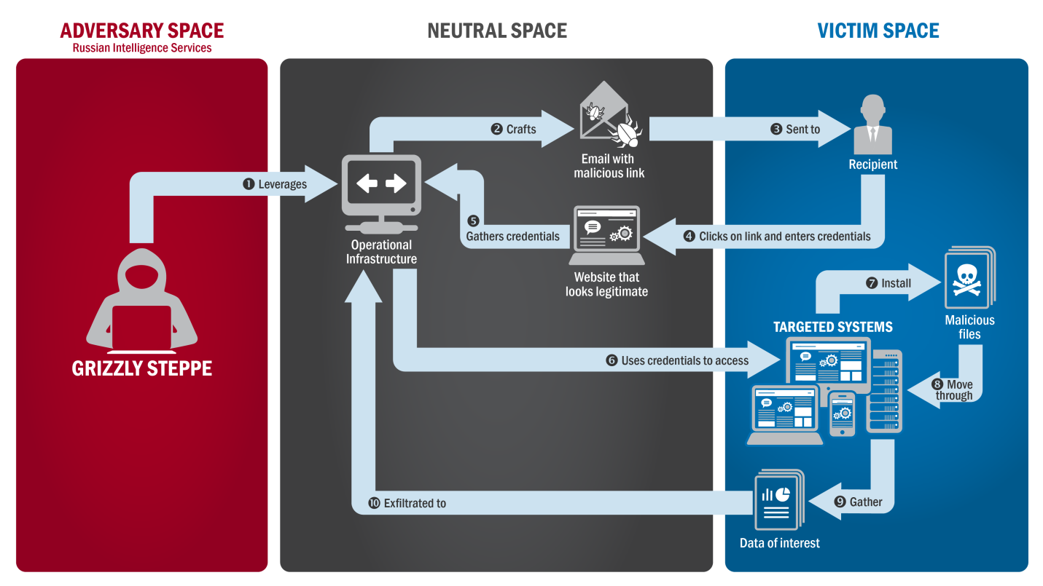

Zero-day Velnerability:

A zero-day (also known as zero-hour or 0-day or day zero) vulnerability is a computer-software vulnerability that is unknown to those (including the vendor of the target software) who would be interested in mitigating the vulnerability. Until the vulnerability is mitigated, hackers can exploit it to adversely affect computer programs, data, additional computers or a network. An exploit directed at a zero-day vulnerability is called a zero-day exploit, or zero-day attack.
Techniques to defend:
- Keep firewalls on

- Change your password

- Authentication

- Turn off universal plug and play.

5) Use secure device
6) Be aware and alert of internet notification and spoofs
7) Update your system periodically

